**Assignment 1**

**Proposed Solution:**

* Data Collection: We will gather historical academic data, including transcripts, attendance records, and standardized test scores, alongside relevant family background information. This holistic approach allows us to paint a comprehensive picture of each student's situation.
* Underprivileged Identification: Leveraging AI algorithms, we will analyze the collected data to identify students exhibiting indicators of underprivileged backgrounds, such as financial hardship, social disadvantage, or limited access to resources.
* Academic Capability Assessment: Moving beyond traditional indicators like grades, our AI model will evaluate individual learning styles, strengths, and weaknesses to understand each student's true academic potential.
* Personalized Insights: Equipped with this data-driven understanding, we will provide students with actionable insights into their performance and potential challenges. This includes identifying specific skills to be improved, highlighting learning gaps, and offering personalized encouragement.
* Tailored Support: We will recommend relevant educational resources beyond the classroom, such as online learning platforms, scholarship opportunities, and targeted learning materials. Additionally, we will connect students with mentors and guidance counselors who can provide ongoing support and motivation.
* Proactive Intervention: By anticipating potential hurdles, we can provide early intervention through tailored guidance and resource allocation, preventing setbacks and promoting academic success. This proactive approach aims to empower students to overcome personal challenges and confidently continue their education.

**Solution Architecture:**

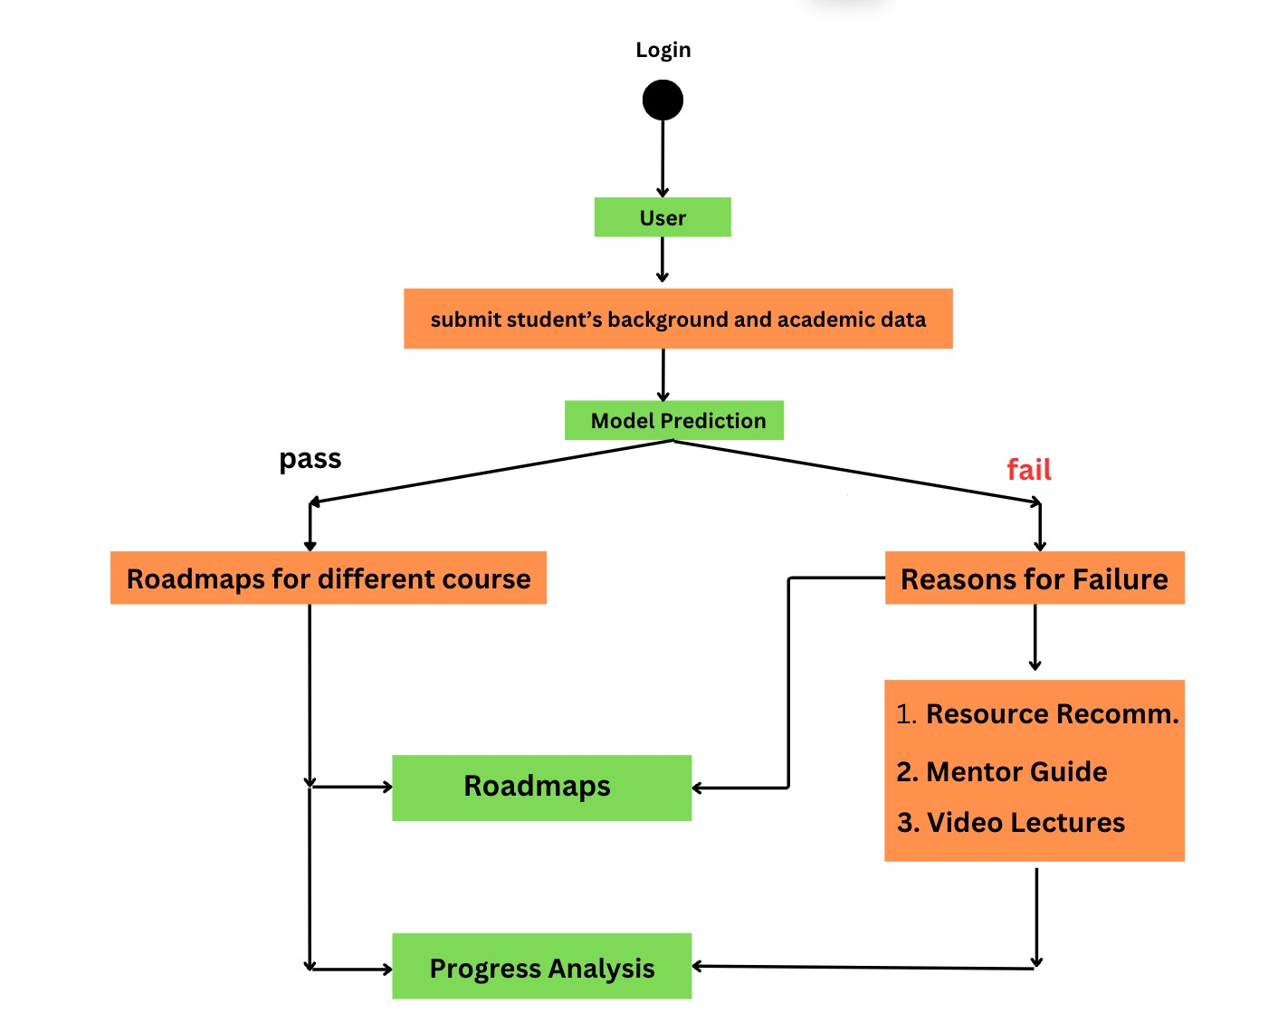

**Unique Features/Innovation Highlights:**

* Identify underprivileged students beyond simple indicators.
* Predict individual learning needs and challenges.
* Offer personalized support, resources, and interventions.
* Motivate and guide students through gamified systems.
* Connect them with mentors and opportunities tailored to their goals.
* Prioritize mental health with dedicated resources and support.

**Progress Update :**

Key Activities:

* Exploratory Data Analysis (EDA): Examining data to uncover patterns, trends, and relationships to inform model development and web integration.
* Model Training: Developing and refining the AI model using the insights from EDA.
* Web Development: Building the web interface to interact with the trained model and deliver results to users.

Recent Accomplishments:

* Data Understanding: Completed initial data analysis using Power BI to gain insights into data structure, quality, and potential problem areas.
* Parallel Workstreams: EDA and model training are ongoing, while web development has commenced concurrently to ensure efficient progress.

Next Steps (potential):

* Finalize EDA: Complete in-depth analysis and address any data quality issues.
* Optimize Model: Improve model accuracy and performance through iterations.
* Integrate Model: Seamlessly incorporate trained model into the web application.
* User Testing: Gather feedback to refine usability and effectiveness.
* Deployment: Launch the integrated solution for broader use.